what is azure databricks?
Azure Databricks is a cloud-based big data analytics and machine learning platform provided by Microsoft Azure in collaboration with Databricks. It is built on Apache Spark and is used to process large amounts of data quickly.
Azure Databricks is a service that allows data engineers, data scientists, and analysts to build data pipelines, analyze large datasets, and create machine learning models using a collaborative workspace.
Key Features
- Apache Spark-based: Fast processing of big data.
- Collaborative notebooks: Supports Python, SQL, Scala, and R in the same environment.
- Integrated with Azure: Works seamlessly with Azure Storage, Azure Data Lake, Azure SQL Database, and other Azure services.
- Scalable: Can process data ranging from a few MBs to petabytes.
- Machine Learning Support: Build, train, and deploy ML models.
- Interactive Workspace: Teams can collaborate on notebooks and projects.
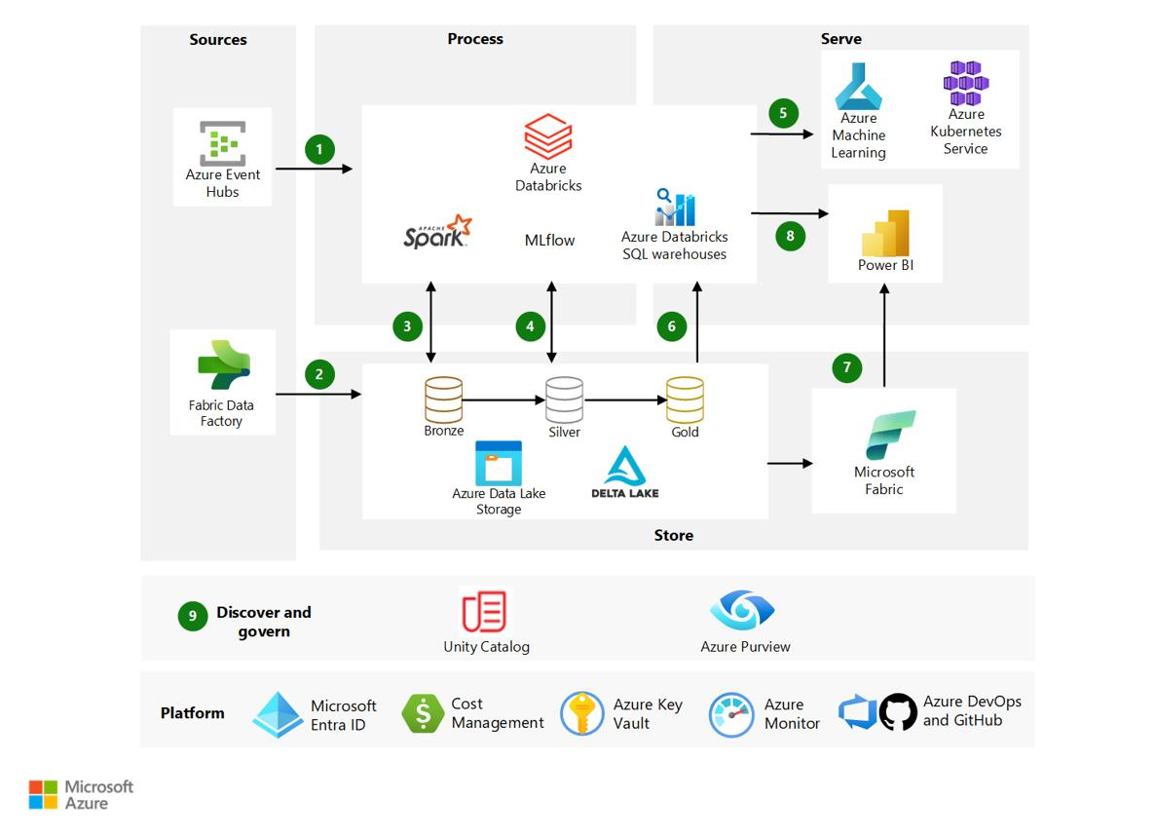

Common Uses
- Big data processing
- ETL (Extract, Transform, Load) pipelines
- Data engineering
- Data analytics
- Machine learning
- Real-time streaming analytics
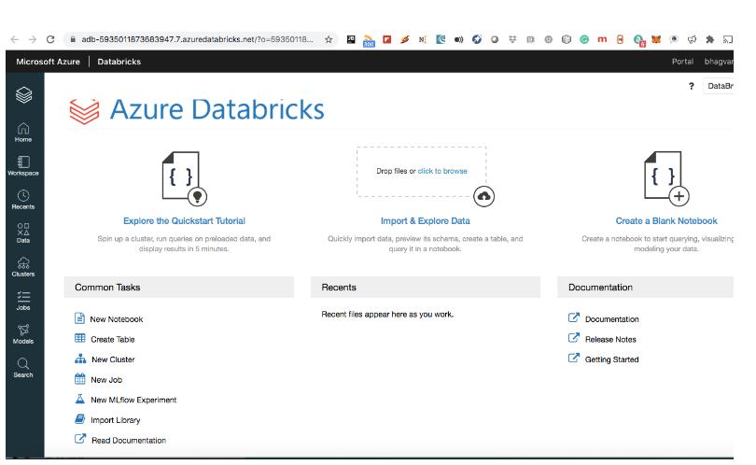

Example
Suppose a smart home company collects millions of sensor readings every day from thousands of devices.
Instead of processing them on a single computer:
- The data is stored in Azure.
- Azure Databricks uses Apache Spark to process the data in parallel across multiple machines.
- It can quickly calculate energy usage, detect abnormal consumption, and generate reports.
Advantages
- High-speed data processing
- Easy integration with Azure services
- Supports multiple programming languages
- Automatic cluster management
- Collaborative notebook environment
- Suitable for AI and machine learning projects

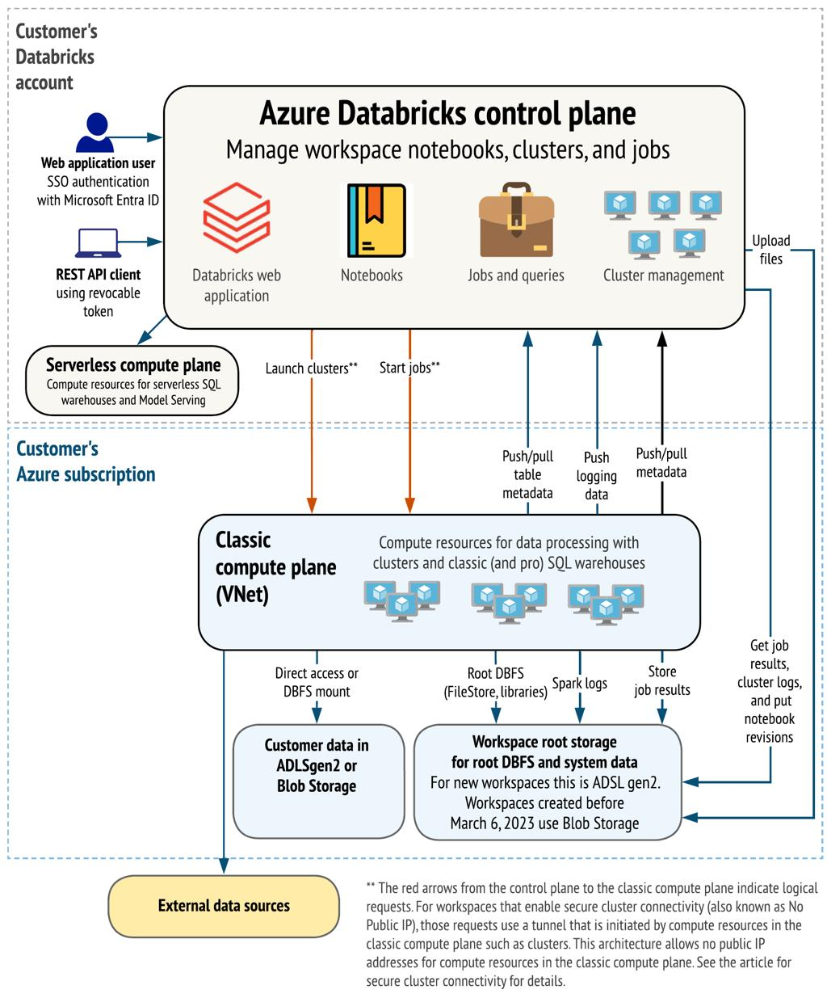
Difference between Azure Databricks and PySpark
PySpark | Azure Databricks
Python API for Apache Spark | Managed cloud platform built on Apache Spark
Runs locally or on clusters | Runs on Azure cloud
Requires manual setup | Automatically manages Spark clusters
Mainly for coding Spark applications | Provides notebooks, collaboration, scheduling, and analytics tools
Azure Databricks is a managed Apache Spark platform on Microsoft Azure that simplifies big data processing, analytics, and machine learning through a collaborative cloud environment.

What are the advantages of using azure databricks?

Azure Databricks offers several advantages for big data analytics, data engineering, and machine learning.
1. High-Speed Data Processing
- Built on Apache Spark, which processes large datasets in parallel.
- Can analyze millions of records much faster than traditional systems.
2. Easy Scalability
- Resources can be increased or decreased based on workload.
- Suitable for both small and very large datasets.
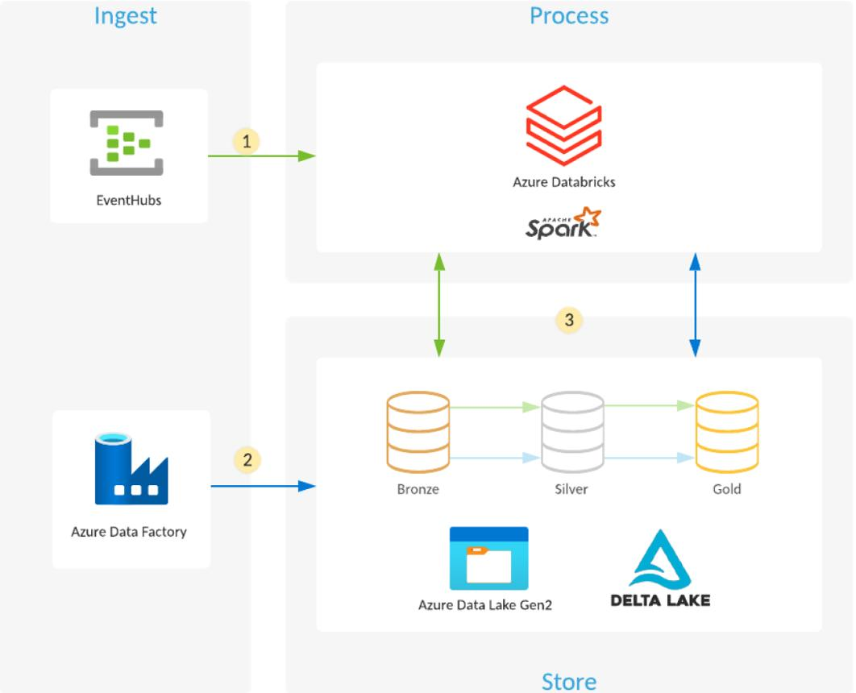

3. Collaborative Workspace
- Multiple users can work together using shared notebooks.
- Teams of data engineers, analysts, and data scientists can collaborate in real time.
4. Supports Multiple Languages
Azure Databricks supports:
- Python
- SQL
- Scala
- R
This flexibility allows different users to work in their preferred language.
5. Seamless Azure Integration
It integrates easily with Azure services such as:
- Azure Data Lake Storage
- Azure Blob Storage
- Azure SQL Database
- Azure Synapse Analytics
6. Built-in Machine Learning Support
- Helps build, train, and deploy machine learning models.
- Includes tools for experiment tracking and model management.
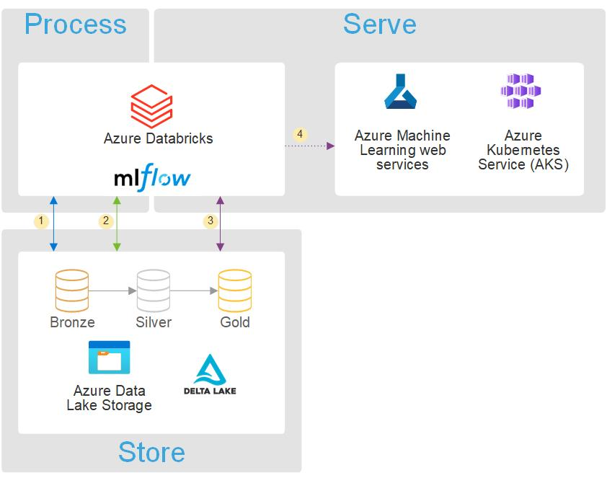

7. Automatic Cluster Management
- Creates and manages Spark clusters automatically.
- Reduces manual configuration and maintenance.
8. Cost-Effective
- Uses a pay-as-you-go model.
- Clusters can be started when needed and stopped when idle to reduce costs.
9. Real-Time Data Processing
- Can process streaming data from IoT devices, sensors, and applications.
- Useful for monitoring systems and live analytics.
10. Strong Security
- Integrates with Azure security features such as identity management, encryption, and role-based access control.
- Helps protect sensitive data and control user access.

what is a workspace?

Think of a workspace as a digital office:
- Team members can work together.
- Files and notebooks are stored in one place.
- Everyone with permission can access and edit shared resources.
In Azure Databricks
A workspace is the central area where users can:
- Create and run notebooks (Python, SQL, Scala, or R)
- Store code and scripts
- Organize folders and projects
- Collaborate with team members
- Manage clusters and jobs
- Visualize data and results

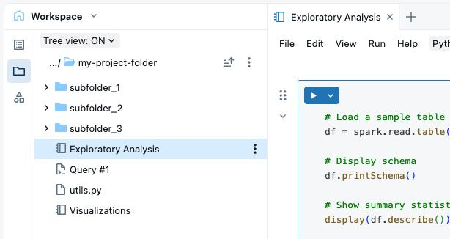

Example
Suppose a company is analyzing smart home energy data.
In the Azure Databricks workspace:
- A data engineer uploads and cleans the data.
- A data scientist builds a machine learning model.
- A data analyst creates reports and charts.
All of them can work in the same workspace, sharing notebooks and results.

Benefits of a Workspace
- Centralized storage for project files
- Easy collaboration among team members
- Organized folders and notebooks
- Shared access with permissions
- Simplifies project management
Real-Life Analogy
Imagine a classroom:
- The classroom is the workspace.
- Students are the users.
- Books, assignments, and whiteboards are the files and notebooks.
- Everyone can work together in the same place.
A workspace is a central collaborative area where people can create, manage, and share project resources and work together efficiently.

What is EDA?
EDA (Exploratory Data Analysis) is the process of examining, summarizing, and visualizing a dataset to understand its structure, patterns, relationships, and potential issues before performing further analysis or building machine learning models.

Why is EDA Important?
EDA helps you:
- Understand the dataset
- Find missing values
- Detect duplicate records
- Identify outliers (unusual values)
- Discover patterns and trends
- Check relationships between variables
- Prepare data for analysis or machine learning

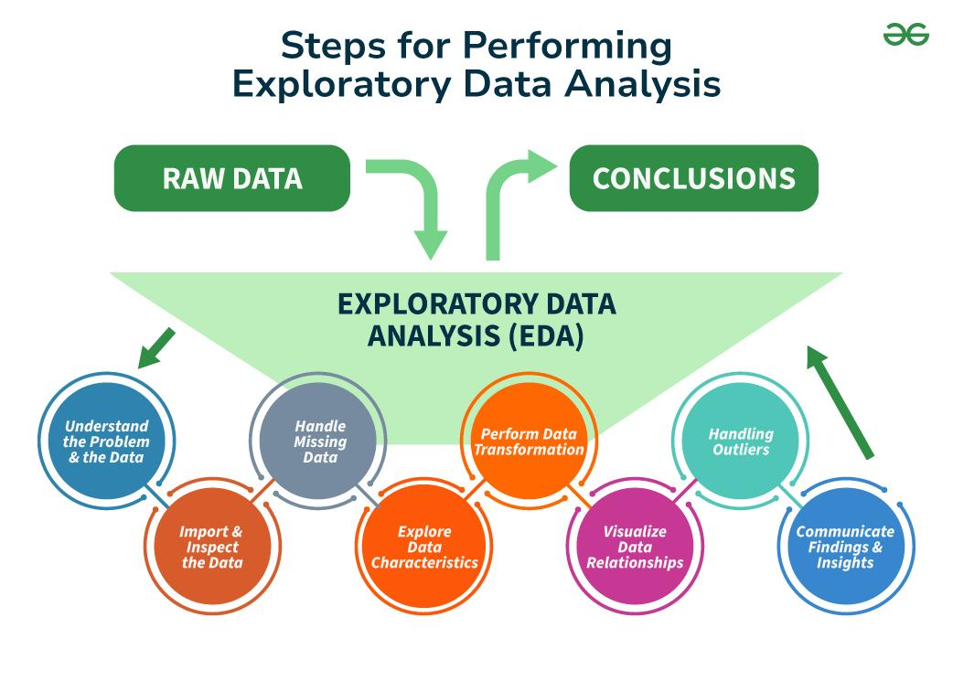

Common Steps in EDA
- Load the dataset
- View the first few rows
- Check data types and structure
- Find missing values
- Remove duplicates
- Generate summary statistics
- Visualize the data using charts such as histograms, bar charts, box plots, and scatter plots
- Identify correlations and patterns

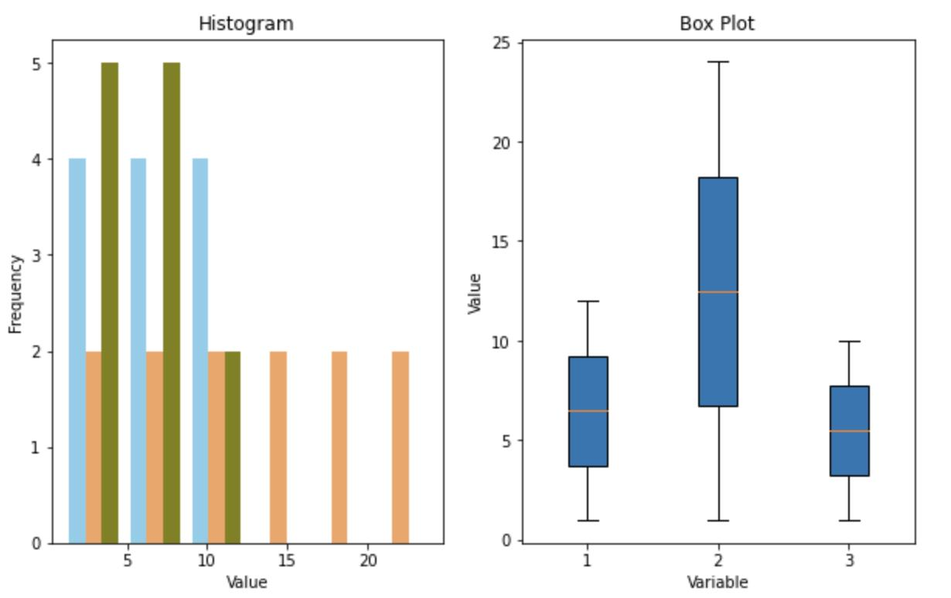

Example
Suppose you have a dataset of smart home energy usage:
Device | Room | Energy (kWh)
Fan | Living Room | 2.5
TV | Living Room | 1.8
AC | Bedroom | 5.6
Fridge | Kitchen | 3.2
Using EDA, you might discover:
- The AC consumes the most energy.
- The Bedroom has the highest total energy usage.
- Some records have missing values that need cleaning.

Advantages of EDA
- Improves understanding of the data
- Helps detect data quality problems
- Reveals trends and patterns
- Supports better feature selection
- Leads to more reliable analysis and machine learning models
In simple terms
EDA is the first step in data analysis, where you explore and understand the data using statistics and visualizations before making decisions or building predictive models.

